# Question 4: Surveillance Ethics and Privacy Risks

**With the use of AI for real-time crowd movement analysis, facial recognition, and sentiment tracking, what are the primary ethical and data privacy risks festival organizers must address to use these tools for security and safety responsibly?**

# When Security Becomes Intrusion

December 2024: Spain fined Club Atlético Osasuna €200,000 and ordered deletion of all biometric data. Same year, Denmark approved facial recognition at FC Copenhagen’s stadium for football—but denied the identical system for concerts.

The principle: biometric surveillance isn’t categorically legal or illegal. It depends on proportionality.

You’re planning festival security. Do the benefits justify scanning attendees who came for music, art, and community? The stakes are high. Over 40 festivals—Bonnaroo, Lollapalooza, Electric Forest—pledged never to use facial recognition after sustained artist campaigns. Red Rocks abandoned Amazon palm-scanning after 300+ artists protested. When surveillance feels invasive, festivals face artist boycotts, attendee backlash, and seven-figure fines.

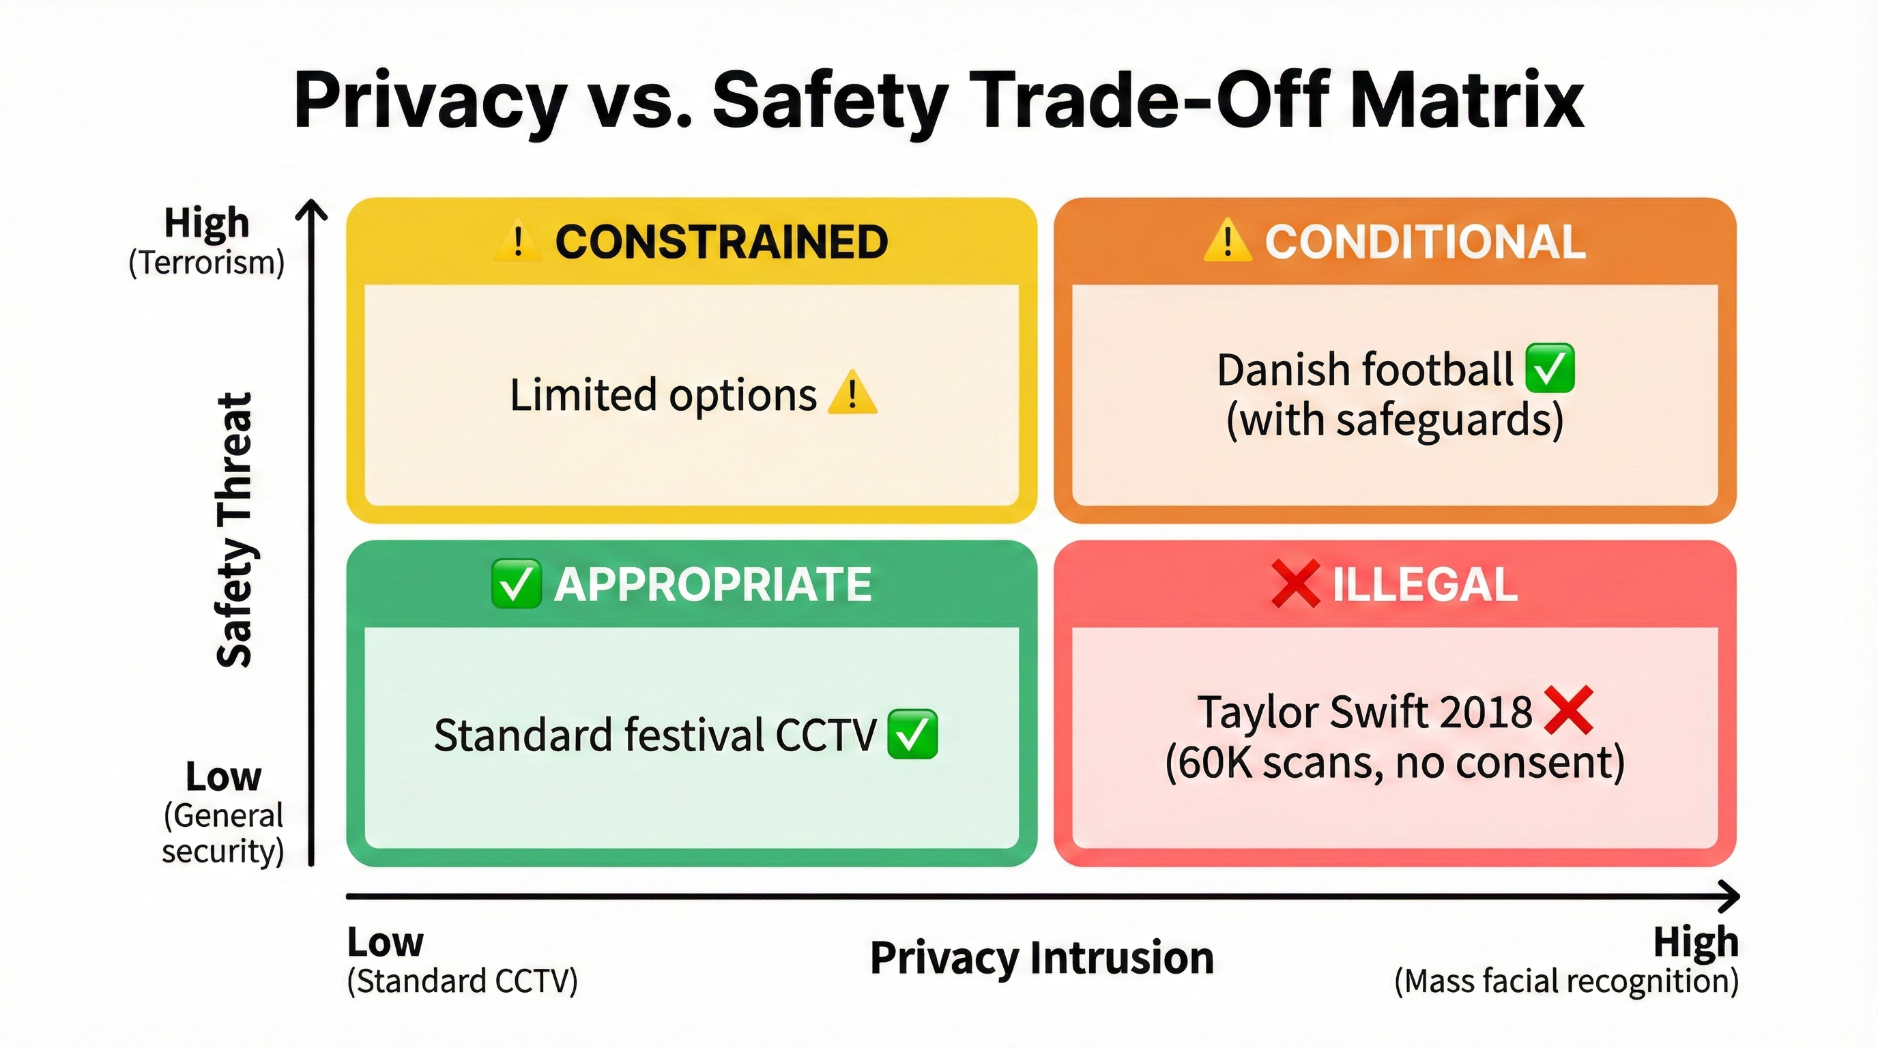

Privacy vs Safety Trade-Off Matrix

**Figure 4.1: Privacy vs Safety Trade-Off Matrix** — When biometric surveillance is appropriate, conditional, constrained, or illegal.

## Risk 1: Covert Surveillance Without Consent

### **Taylor Swift Rose Bowl (2018)**

May 2018. Sixty thousand Taylor Swift fans walked past kiosks showing rehearsal footage—behind-the-scenes content to entertain the queue. What they didn’t know: each screen was scanning their faces, cross-referencing against a database of Swift’s known stalkers.

No signage disclosed the scanning. No opt-in checkbox. No way to decline. Attendees thought they were watching exclusive content. They were being catalogued.

When Rolling Stone broke the story, the ACLU condemned it as “unacceptable surveillance.” Seven years later, regulators still cite the incident in guidance on covert biometric processing. The reputational damage likely outweighs any security benefit from stalker identification.

Had this occurred in the EU, Swift’s team would face GDPR violations for transparency (Article 5), lawfulness (Article 6), and special category data protections (Article 9). Potential fines: €20 million or 4% of global turnover. Under California CCPA, biometric data is “sensitive personal information” requiring notice and opt-out rights. Covert collection may violate Civil Code § 1798.100.

### **Madison Square Garden (2022-2024)**

MSG Entertainment deployed facial recognition to identify attorneys from firms suing the company—then ejected them mid-event, even when attending as paying customers.

An attorney celebrating her daughter’s birthday at a Rockettes show was pulled aside and removed. A lawyer chaperoning a Girl Scout troop was escorted out before the performance started. A personal injury attorney on a date was identified at the door and expelled.

MSG argued property rights: private venue, we can refuse anyone. But 100+ artists announced boycotts by July 2023. The New York Legislature passed legislation banning the practice in June 2024. Attorneys now avoid MSG venues entirely—a chilling effect on the legal profession itself.

The regulatory outcome: legal doesn’t mean socially acceptable. Even lawful surveillance triggers boycotts and legislative prohibition. For festivals, the Danish DPA requires “substantial public interest.” Using facial recognition for business disputes, competitor exclusion, or personal vendettas fails that test.

## Risk 2: Regulatory Violations and €200,000 Fines

### **Mobile World Congress 2021**

The GSMA deployed BREEZZ facial recognition for conference entry. It was optional—43% opted in, 57% used manual ID check. Voluntary enrollment should have satisfied regulators.

Spain’s data protection authority fined them €200,000 anyway.

The violation: Article 35 GDPR requires a Data Protection Impact Assessment before deploying biometric systems. The GSMA submitted one, but regulators called it “merely nominal.” It failed to examine necessity (were there alternatives?), proportionality (does convenience justify biometric processing?), specific risks to attendees, or safeguards to mitigate those risks.

The lesson: opt-in consent doesn’t equal GDPR compliance. Even voluntary enrollment doesn’t prevent six-figure fines for inadequate documentation. Conducting a rigorous Data Protection Impact Assessment (DPIA) for complex biometric systems is a resource-intensive process, often incurring external legal and technical consulting fees estimated between €20,000 and €80,000. This significant upfront investment is necessary to mitigate the risk of severe enforcement, exemplified by the €200,000 fines imposed on organizations like the GSMA and Club Atlético Osasuna for inadequate biometric compliance. Furthermore, with the advent of the EU AI Act, compliance costs for such ‘High-Risk’ systems are projected to rise further, potentially exceeding €100,000 for full conformity assessments.

### **Club Atlético Osasuna**

December 2024. Spain’s AEPD fined Osasuna €200,000, ordered deletion of all biometric data, and prohibited further facial recognition use at El Sadar Stadium.

The proportionality failure: “Marginal benefits did not justify the processing” when QR codes and digital tickets already enabled efficient access. Convenience alone isn’t sufficient justification.

The same year, La Liga received a €1,000,000 fine for requiring biometric identification without proper DPIA. Seven-figure penalties demonstrate escalating enforcement.

## Risk 3: Algorithmic Bias and Discriminatory Harm

### **NIST Test (2019)**

The National Institute of Standards and Technology evaluated 189 commercial facial recognition algorithms. The findings: false positive rates run 10-100 times higher for Asian and African American faces compared to Caucasian faces. Indigenous individuals face similarly elevated error rates. Women are misidentified more than men across most systems.

Not all systems are equally biased, but bias is pervasive. Deploying without vendor-specific demographic testing introduces discriminatory risk.

### **Seven Wrongful Arrests**

Robert Williams was detained for 30 hours in Detroit for shoplifting he didn’t commit. The facial recognition system misidentified him. It was the first documented wrongful arrest from facial recognition technology.

Porcha Woodruff was eight months pregnant when Detroit police arrested her for carjacking. She couldn’t have committed the crime. The system got it wrong.

Randal Reid was arrested in Georgia for crimes committed in Louisiana. He was detained for six days despite being in another state when the crimes occurred.

The pattern: six of seven documented wrongful arrest cases involve Black individuals.

For festivals, the math is stark. A 1% false positive rate at a 50,000-person festival means 500 innocent attendees get flagged. That creates civil liability for wrongful ejection, reputational damage when incidents go public, and BIPA violations in Illinois carrying $1,000-5,000 statutory damages per person.

## Risk 4: Function Creep

Data collected for security gets repurposed without renewed consent. The progression is gradual and predictable.

Year one: “We’re using facial recognition to identify banned individuals—hooligans and stalkers.”

Year two: “We’re also using it to identify VIP guests so we can welcome them with premium service.”

Year three: “We’re sharing anonymized crowd movement data with sponsors to help them target advertising.”

Year four: “We’re selling aggregate biometric templates to third-party analytics firms.”

GDPR Article 5(1)(b) prohibits this: data collected for one purpose cannot be repurposed without new legal basis. CCPA requires explicit consent for biometric data sales. But enforcement depends on audits and transparency—both rare at festivals.

Clearview AI scraped billions of facial images from social media for “law enforcement use,” then marketed the database to private companies. The UK fined them £7.5 million and banned processing of UK data. Australia ordered deletion of Australian images. France fined them €20 million.

The mitigation: explicit purpose statements in privacy policies, technical restrictions preventing data access outside security teams, regular audits of who accessed biometric data and why, and annual transparency reports for large-scale deployments.

## Risk 5: Data Breaches and Biometric Permanence

You can change a stolen password. You cannot change your face.

Imagine a festival’s biometric database gets hacked. Attackers now have unchangeable identifiers usable across any system that recognizes those biometrics. The breach isn’t theoretical.

Biostar 2 exposed 27.8 million fingerprint and facial recognition records through an unsecured database in 2019. India’s Aadhaar system potentially compromised 1.1 billion citizens’ biometric data in 2018. Suprema exposed one million people’s biometric data in a security lapse the same year.

GDPR requires 72-hour breach notification to authorities (Article 33) and direct notification to affected individuals if the breach creates high risk (Article 34). Failure to notify carries fines up to €10 million or 2% of global turnover.

Under Illinois BIPA, individuals can sue directly. Damages run $1,000 per negligent violation or $5,000 per reckless violation. A breach affecting 10,000 attendees could generate $10-50 million in statutory damages before compensatory damages.

## Risk 6: Chilling Effects on Free Expression

Knowledge of biometric surveillance changes behavior. Attendees avoid festivals with politically controversial artists. They leave dissenting slogans off their t-shirts. They skip environmental or social justice activism at events they know are monitored.

Research documents the pattern: people search less for information on sensitive topics when aware of monitoring, self-censor online expression when privacy is compromised, and conform to expected behavior when surveillance is visible.

Festivals historically serve as spaces for countercultural expression, political dissent, and identity exploration. Surveillance perceived as monitoring beliefs rather than ensuring safety undermines that culture.

Post-9/11, increased surveillance at political rallies led to documented attendance decreases at events featuring controversial speakers, according to ACLU research. The chilling effect is measurable.

The mitigation: transparent, limited-purpose surveillance stating “we monitor crowd density for safety, not individual identities.” Technical safeguards preventing individual identification, like Paris 2024’s approach. No law enforcement sharing unless legally compelled and publicly disclosed.

## Risk 7: Vendor Lock-In and Data Ownership

When festivals hire Wicket, NEC, or Clear for facial recognition, who owns the data?

Wicket’s COO was direct: “Customers can do what they want with the data.” Translation: venues own the biometric data and can monetize it however they choose.

The implications unfold predictably. The festival collects your biometric data through a vendor system. The festival—not you—owns that data. They could sell it to third parties, use it for marketing, or share it with law enforcement. You have no ongoing control even if you initially consented.

GDPR provides protection: right to data portability (Article 20), right to erasure (Article 17), right to know who controls and processes your data (Article 13). In the US, without comprehensive federal privacy law, data ownership is governed by Terms of Service that attendees rarely read, state laws that vary wildly, and vendor contracts that remain opaque.

## Danish DPA Test: Concerts ≠ Football

December 2024. FC Copenhagen proposed facial recognition at Parken Stadium for both football matches and concerts. Denmark approved it for football. Denied it for concerts.

The football rationale was straightforward: documented hooliganism history, banned individuals on police suspension lists, previous violent incidents requiring intervention, and substantial public interest under Danish Data Protection Act §7(4) in preventing violence.

The concert rationale was equally clear: no documented security problems specific to concerts at the venue, no violence history, no banned individual lists, and QR codes plus digital tickets already providing adequate access control. Marginal convenience doesn’t justify biometric processing.

The principle: biometric surveillance must be proportionate to documented threats, not merely convenient or efficient. Festivals cannot claim “general security” as justification. They must show specific, substantial risks that less intrusive measures cannot address.

Four questions test proportionality:

First: Is there documented incident history? If the answer is “no incidents, we just want faster entry,” proportionality likely fails.

Second: Are less intrusive alternatives available? RFID wristbands, mobile tickets, security personnel, and metal detectors exist and work adequately. If they do, proportionality fails.

Third: What’s the false positive rate and who bears the cost? At a 50,000-person festival with a 1% error rate, 500 innocent attendees get flagged. Are you prepared to handle 500 wrongful ejections?

Fourth: Can you demonstrate GDPR Article 35 compliance? Conducting a rigorous DPIA for complex biometric systems requires external legal and technical consulting fees estimated between €20,000 and €80,000. This upfront investment mitigates the risk of severe enforcement—the GSMA and Club Atlético Osasuna each received €200,000 fines for inadequate biometric compliance. Proportionality must be documented, not assumed.

## Responsible Surveillance: The Paris 2024 Model

Paris deployed AI-powered crowd monitoring across 35 Olympics venues and metro stations using Cityvision software by Wintics. The system explicitly excluded facial recognition.

The capabilities: crowd surge detection, abandoned object identification, weapon detection, fire and smoke detection, and anonymized density analysis. The system knows “100 people in this zone,” not “John Smith is in this zone.”

The regulatory framework made it work: France Law No. 2023-380 provided specific legal authorization. CNIL oversight ensured privacy commission supervision. The authorization expires March 31, 2025—not perpetual surveillance. Public disclosure detailed system capabilities and limitations.

Why it works: the deployment was proportionate to mega-event security needs, privacy-by-design excluded the most intrusive capability, transparent governance included CNIL oversight and time limits, and specific authorization replaced blanket surveillance.

Festivals can implement AI crowd density monitoring—fluid dynamics models, surge prediction, bottleneck identification—without biometric identification. Paris 2024 demonstrates feasibility.

## Opt-In Systems: Why Sports Succeeded, Festivals Failed

Cleveland Browns deployed Wicket facial recognition for stadium entry. Over 50% of season ticket holders enrolled. On game day, 16% of attendees use facial entry. Entry time drops to two seconds. The team saves $8,000 per lane in staffing costs. Once enrolled, 0% opt out—everyone who tries it keeps using it.

Why it worked: season ticket holders attend eight or more games per year, so one-time enrollment pays off over the season. NFL stadiums have documented violence and contraband issues justifying heightened security. Traditional gates remain operational with no penalty for declining facial entry. The value proposition is concrete: “Get in four times faster when rushing from tailgating,” as COO Jeff Boehm explained. The Browns own the data, not a third-party vendor with murky incentives.

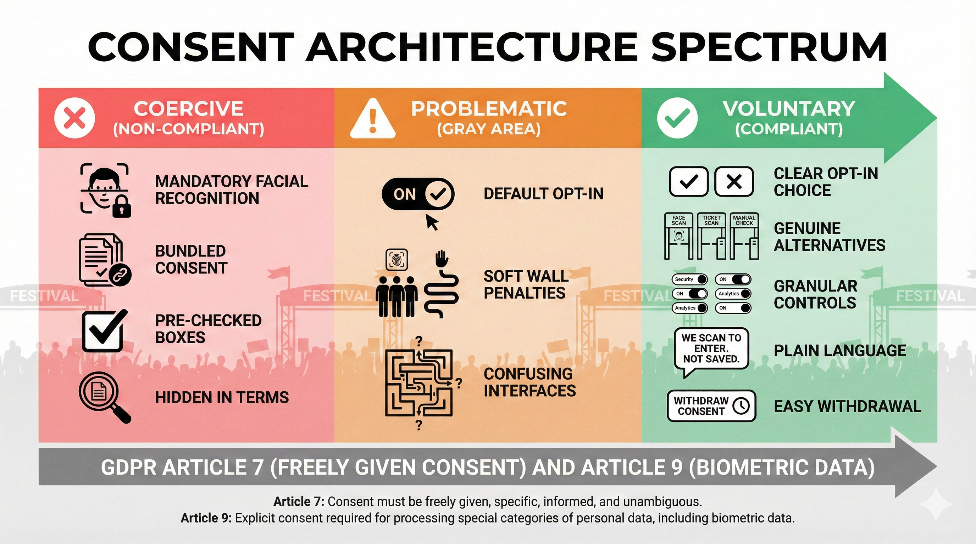

Consent Architecture Spectrum

**Figure 4.2: Consent Architecture Spectrum** — GDPR-compliant consent patterns from coercive (illegal) to voluntary (compliant).

Over 40 festivals rejected the same technology. Fight for the Future secured pledges from Bonnaroo, Austin City Limits, Lollapalooza, Outside Lands, Electric Forest, SXSW, and 34 more. Tom Morello, Zach de la Rocha, Amanda Palmer, and 300+ musicians signed opposition letters.

The artist statement was unequivocal: “Fans should feel safe and respected at shows, not subjected to invasive surveillance that can be used to target and harass them.”

Live Nation and AEG stated future use would be “strictly opt-in” but functionally pledged not to deploy given artist opposition. When 300+ artists protested Amazon One palm-scanning at Red Rocks in March 2022, Denver Arts & Venues confirmed: “This isn’t a planned activation.”

The difference: concerts mean one-time attendance with minimal return-on-investment for enrollment. Most festivals have no documented violence history, so proportionality fails. Artist relationships matter more than operational efficiency. Festival culture values spontaneity over optimized throughput.

The Danish DPA formalized the distinction: Concerts ≠ Football for proportionality purposes.

## Regulatory Landscape

### **GDPR (EU/UK)**

Biometric data is “special category” under Article 9, requiring explicit consent or another Article 9(2) condition.

For private festivals, two legal bases exist. First: explicit consent under Article 9(2)(a), which requires genuine alternatives that are equally accessible, withdrawal as easy as granting consent, and no power imbalance making consent non-voluntary. Second: substantial public interest under Article 9(2)(g), requiring basis in EU or Member State law, proportionality to the aim pursued, and—per Danish DPA interpretation—documented security incidents.

Article 35 mandates Data Protection Impact Assessments before deployment. Violations draw €200,000+ fines (Mobile World Congress, Osasuna). Unlawful processing under Article 9 carries penalties up to €20 million or 4% of global turnover.

### **BIPA (Illinois)**

Illinois enacted the strictest US biometric law: written consent required before collection, disclosure of purpose and retention schedule mandatory, private right of action allowing individuals to sue directly, and statutory damages of $1,000 for negligent violations or $5,000 for reckless violations.

Meta settled for $1.375 billion in 2024. Google settled for $100 million in 2023. Clearview AI faces ongoing actions.

Lollapalooza operates in Illinois. Any biometric deployment without BIPA compliance creates class action risk.

### **EU AI Act (Effective February 2, 2025)**

The Act bans real-time biometric identification in public spaces for private entities. Narrow law enforcement exceptions require judicial authorization. Databases built from untargeted web scraping are banned, targeting Clearview AI-style systems. Emotion recognition in workplace or education settings is prohibited.

Post-event biometric identification and AI affecting access to services are classified as high-risk, requiring conformity assessment.

Prohibited use carries fines of €35 million or 7% of global turnover, whichever is higher. Non-compliance with high-risk requirements: €15 million or 3% of global turnover.

For festivals: real-time facial recognition at entry is banned. Post-event analysis—identifying specific attendees from footage after an incident—is high-risk and requires conformity assessment.

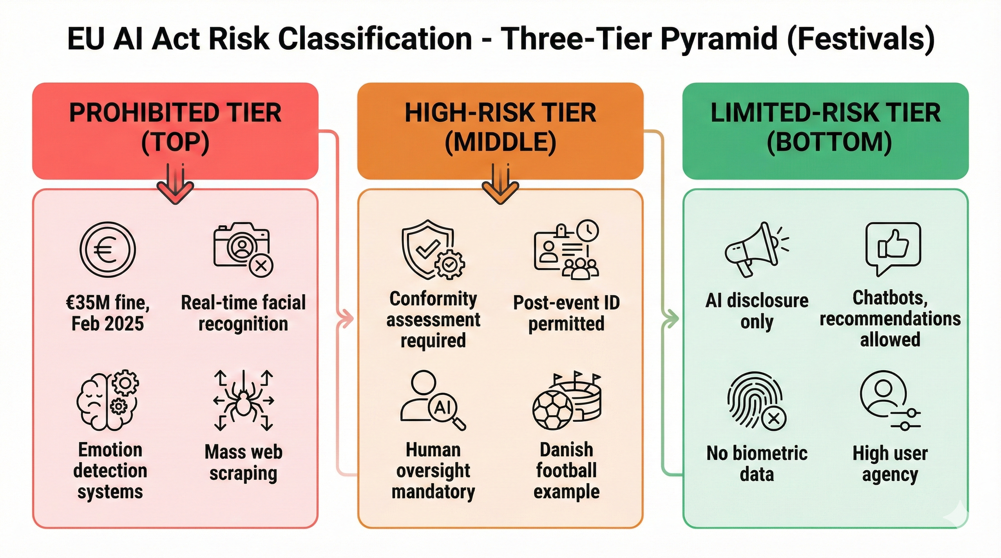

EU AI Act Risk Classification

**Figure 4.3: EU AI Act Risk Classification** — Three-tier framework: prohibited, high-risk, limited-risk.

## If You Must Deploy Surveillance

Before deployment, complete a rigorous DPIA. Conducting a Data Protection Impact Assessment for complex biometric systems is a resource-intensive process, often incurring external legal and technical consulting fees estimated between €20,000 and €80,000. This significant upfront investment is necessary to mitigate the risk of severe enforcement, exemplified by the €200,000 fines imposed on organizations like the GSMA and Club Atlético Osasuna for inadequate biometric compliance. Consult your Data Protection Officer if GDPR applies. Verify legal basis under GDPR Article 9(2) or BIPA. Check EU AI Act prohibitions if operating in the EU. Assess proportionality using the Danish framework.

On the technical side, test for demographic bias using NIST-style evaluations. Establish false positive and negative rates with confidence intervals. Implement restricted capture zones with no passive scanning. Build robust fallback systems for failures. Encrypt biometric templates and never store raw images.

For consent architecture, provide genuine alternative entry that’s equally accessible. Design symmetry in choice—opting out should be as easy as opting in. Use progressive disclosure with essential information upfront. Avoid dark patterns like hidden consents or automatic resets. Enable simple withdrawal with data deletion.

Governance requires limiting retention periods to delete data after the event or season. Restrict access to security teams only with audit trails. Prohibit function creep—no repurposing data without new consent. Plan breach response procedures for 72-hour GDPR notification. Issue annual transparency reports for large-scale deployments.

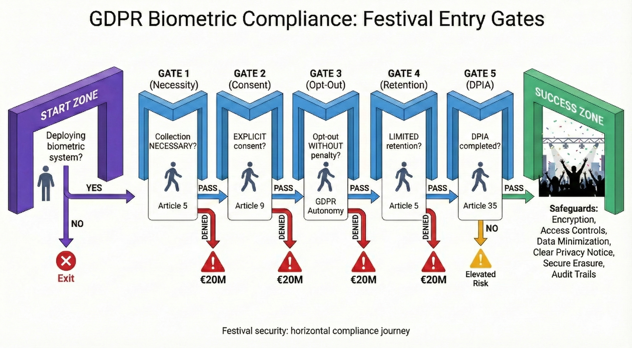

GDPR Biometric Compliance Flowchart

**Figure 4.4: GDPR Compliance Decision Tree** — Five checkpoints for evaluating biometric system legality.

## The Bottom Line

Every festival faces a choice Spanish regulators priced at €200,000: deploy responsibly or face consequences.

The evidence is clear. Over 40 festivals chose rejection over reputational risk. Denmark denied concerts while approving football, making proportionality decisive. Paris 2024 demonstrated effective crowd monitoring without facial recognition. Fines exceeding €200,000 are now routine for inadequate DPIAs. Artist boycotts numbering 100+ at MSG and attendee backlash at Red Rocks create existential threats.

The responsible path exists: AI crowd density monitoring using fluid dynamics and surge prediction, anonymous environmental sensors following the Paris 2024 model, RFID wristbands for access control as Tomorrowland deployed for 50,000+ attendees, and trained security personnel still required even with AI for fallback.

Biometric surveillance at festivals isn’t impossible—it’s rarely proportionate. Unless festivals have documented security incidents justifying intrusion like hooliganism, terrorism threats, or systematic violence, regulators increasingly apply the Danish standard: Concerts ≠ Football.

For students and professionals entering the festival industry: the question isn’t whether you’ll encounter pressure to deploy surveillance AI. It’s whether you’ll have frameworks to say “no” when deployment is inappropriate, and courage to advocate for privacy-respecting alternatives that work.

The €200,000 fines, artist boycotts, and regulatory denials send a clear message: convenience isn’t sufficient justification for biometric processing. Festivals that learn this lesson avoid consequences. Those that don’t learn expensively.

**Sources:**

* [ACLU: The problem with using face recognition on fans at a Taylor Swift concert](https://www.aclu.org/news/privacy-technology/problem-using-face-recognition-fans-taylor-swift)
* [ACLU: Williams v. City of Detroit - Face recognition false arrest](https://www.aclu.org/cases/williams-v-city-of-detroit-face-recognition-false-arrest)
* [AEPD (Spain): La Liga €1,000,000 fine for biometric processing without DPIA - Decision EXP202315637](https://gdprhub.eu/index.php?title=AEPD_(Spain)_-_EXP202315637)
* [Big Brother Watch: Stop facial recognition campaign report](https://bigbrotherwatch.org.uk/campaigns/stop-facial-recognition/report/)
* [Büchi, M., Festic, N., & Latzer, M. (2022). The chilling effects of digital dataveillance. Big Data & Society](https://journals.sagepub.com/doi/10.1177/20539517211065368)
* [CBS News: Madison Square Garden faces scrutiny over facial recognition technology](https://www.cbsnews.com/news/madison-square-garden-face-recognition-illegal-new-york-attorney-general-letitia-james/)
* [Center for Democracy and Technology: EU AI Act brief - Privacy and surveillance](https://cdt.org/insights/eu-ai-act-brief-pt-2-privacy-surveillance/)
* [Danish Data Protection Authority: Decision 2024-51-0012 on FC Copenhagen facial recognition](https://gdprhub.eu/index.php?title=Datatilsynet_(Denmark)_-_2024-51-0012)
* [ECNL: Hungary’s new biometric surveillance laws violate AI Act](https://ecnl.org/news/hungarys-new-biometric-surveillance-laws-violate-ai-act)
* [Electronic Frontier Foundation: About Face - EFF’s work on face recognition](https://www.eff.org/aboutface)
* [European Parliament: EU AI Act - First regulation on artificial intelligence](https://www.europarl.europa.eu/topics/en/article/20230601STO93804/eu-ai-act-first-regulation-on-artificial-intelligence)
* [Fight for the Future: Ban facial recognition from festivals](https://festivals.banfacialrecognition.com/)
* [GDPR Article 9: Processing of special categories of personal data](https://gdpr-info.eu/art-9-gdpr/)
* [National Academies of Sciences: Facial recognition technology - Current capabilities, future prospects, and governance](https://nap.nationalacademies.org/read/27397/chapter/5)
* [National Institute of Standards and Technology (2019): Face Recognition Vendor Test Part 3 - Demographic Effects](https://nvlpubs.nist.gov/nistpubs/ir/2019/NIST.IR.8280.pdf)
* [New York Attorney General: Attorney General James seeks information from Madison Square Garden regarding use of facial recognition technology](https://ag.ny.gov/press-release/2023/attorney-general-james-seeks-information-madison-square-garden-regarding-use)
* [New York State Bar Association: Privacy vs. security - The legal implications of using facial recognition technology at entertainment venues](https://nysba.org/privacy-vs-security-the-legal-implications-of-using-facial-recognition-technology-at-entertainment-venues/)
* [NPR: Facial recognition technology at MSG has sparked new concerns](https://www.npr.org/2023/01/21/1150289272/facial-recognition-technology-madison-square-garden-law-new-york)
* [Pew Research Center (2022): Public more likely to see facial recognition use by police as good rather than bad for society](https://www.pewresearch.org/internet/2022/03/17/public-more-likely-to-see-facial-recognition-use-by-police-as-good-rather-than-bad-for-society/)
* [Privacy International: Blank space - Why Taylor Swift doing facial recognition is a bad idea](https://privacyinternational.org/news-analysis/2547/blank-space-why-taylor-swift-doing-facial-recognition-bad-idea)
* [Rolling Stone: Taylor Swift used facial recognition at concert to identify stalkers](https://www.rollingstone.com/music/music-news/taylor-swift-facial-recognition-concerts-768741/)
* [Stadium Tech Report: Wicket’s facial authentication technology a ticket to success for Cleveland Browns](https://stadiumtechreport.com/feature/wickets-facial-authentication-technology-a-ticket-to-success-for-cleveland-browns/)
* [UNESCO: Recommendation on the Ethics of Artificial Intelligence](https://www.unesco.org/en/articles/recommendation-ethics-artificial-intelligence)